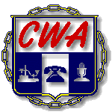

21st ANNUAL CWA/AT&T CHARITY GOLF TOURNAMENT

WHO: FIRST 36 - 4 PERSON TEAMS
WHEN: SATURDAY, June13th, 2020 - 8:00AM SHOTGUN START
Registration starts at 7:00AM
WHERE: EAGLES LANDING-BELTON, MISSOURI
4200 Bong Ave, Belton, MO 64012

THE 21st ANNUAL CWA/AT&T CHARITY GOLF TOURNAMENT IS APPROACHING. WITH THIS IN MIND, THE TOURNAMENT COMMITTEE IS CONTACTING ALL PREVIOUS AND/OR NEW SPONSORS TO AGAIN PARTICIPATE IN A WORTHY CAUSE FOR CHARITY.

BECAUSE OF YOUR GENEROSITY IN 2019, WORKING FAMILIES

RECEIVED A $5,500 DONATION

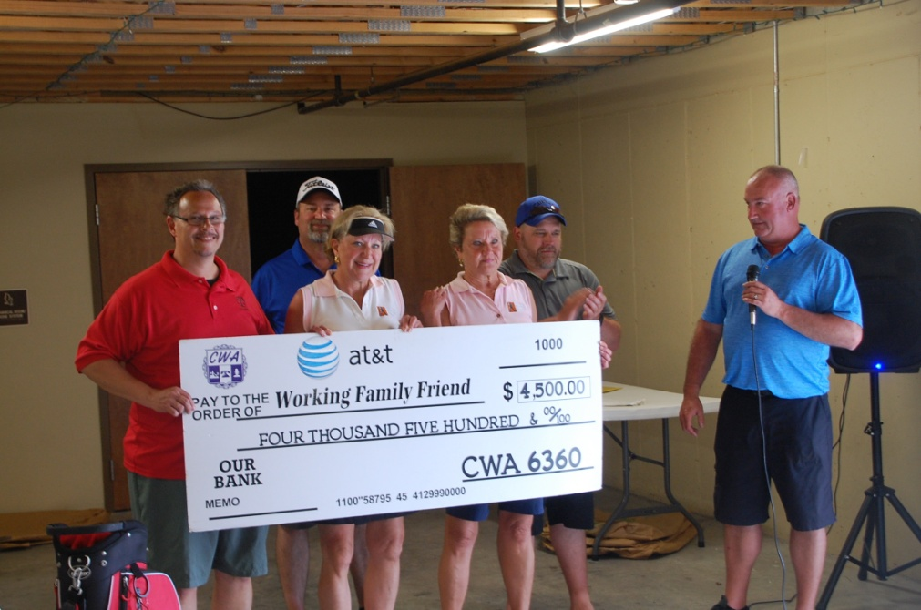

THE 2020 CHARITY IS
Working Families Friend

RETURN THIS PAGE WITH PAYMENT

Sponsor Name:________________________________________________________

------------------------------------------------------------------------------------------------------
Make checks payable to CWA/AT&T Charity Golf Classic

Send to: CWA Local 6360, 6415 Universal Ave Kansas City MO 64120

Questions: Call Darrick Inscho at (816) 561-6360 or email: darrick@cwa6360.org

- $300.00 – Bronze Sponsor w/ Hole Sign and one (1) player

- $500.00 – Silver Sponsor w/ Hole Sign and two (2) players

- $750.00 – Gold Sponsor w/ Hole Sign and three (3) players

- $1000.00 – Platinum Sponsor w/ Hole Sign and four (4) Players

Signature________________________________

LIMITED TO THE FIRST 24 SPONSORED PLAYERS

PLAYER NAMES:

NAME: ____________________(Capt.) TELE # ________________________

NAME :_________________________TELE# _________________________

NAME: _________________________ TELE# _________________________

NAME: _________________________ TELE# _________________________

Please provide emails if possible

